How to Run.

1. Open the Places.xlsx file. You should see the below content.

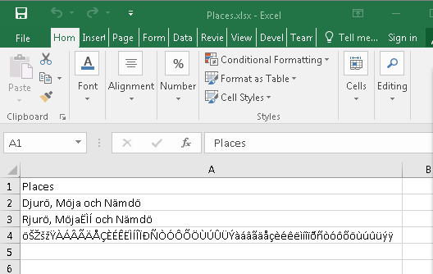

1. Open the mapper.xlsx file and right click on the “Data” query and select “Invoke”

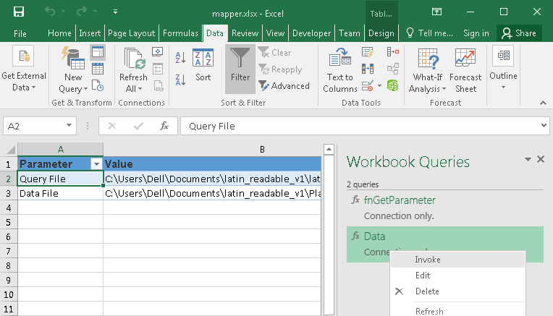

1. In the new window, press “Invoke” again. This will ask for the Latin Column name. In the example, “Places”

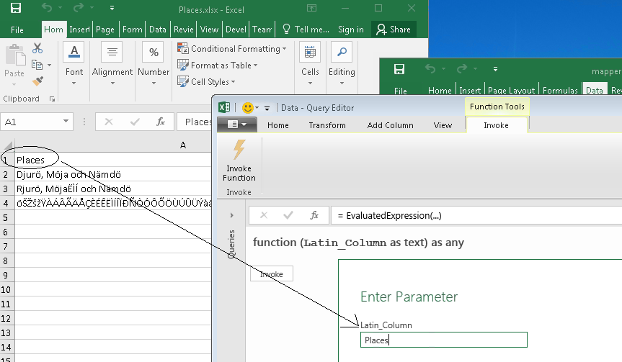

1. Press Ok. And you should see the value.